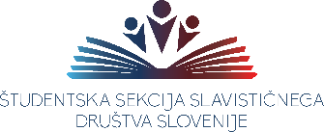

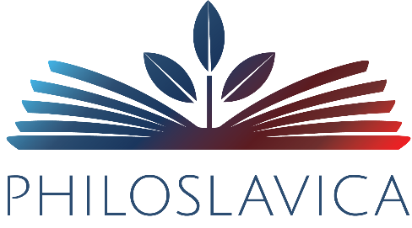

Prijavni obrazec
Application form

Ime
First Name
Priimek
Surname
Izobraževalna ustanova
Educational Institution
Oddelek in leto študija
Department and year of study
E-naslov
E-mail address

Prijavljam se na 11. Simpozij mladih slavistov:
Dialog med središči in obrobji v slovanskih jezikih in literaturah
I am applying for the 11th Symposium of Young Slavists:
The Dialogue between Centres and Peripheries in Slavic Languages and Literatures

Naslov prispevka
Title of the paper²
Naslov prispevka v drugem jeziku
Title of the paper in the second language²
Jezik predstavitve
Language of the presentation
Povzetek / Summary

Povzetek v drugem jeziku/ Summary in the second language

Kratek življenjepis avtorja v jeziku prispevka / Short CV of the author in the language of the paper

Kratek življenjepis avtorja v drugem jeziku / Short CV of the author in the second language

Katerikoli slovanski jezik ali angleščina. / Any Slavic language or English.
Če je jezik prispevka angleščina, morata biti drugi naslov in povzetek v slovanskem jeziku. / If the language of the paper is English, the second title and the second summary have to be in a Slavic language.
Katerikoli slovanski jezik ali angleščina. / Any Slavic language or English.
Če je jezik prispevka angleščina, morata biti drugi naslov in povzetek v slovanskem jeziku. / If the language of the paper is English, the second title and the second summary have to be in a Slavic language.

